JECRC
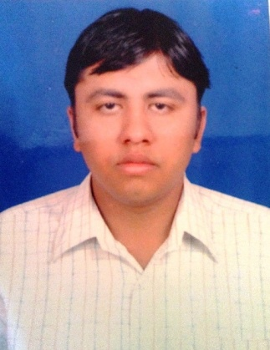Affix and Attest
passport
size photograph
JAIPUR

INDIVIDUAL FACULTY DATA SHEET
Name of the faculty member | : | PRAVIN KUMAR SHARMA
Present Designation | : | ASSISTANT PROFESSOR
Email Id: pravinkumarsharma.ece@jecrc.ac.in

Contact Details: 9460556454

I. Particulars of Educational Qualification: (only completed)

Category | Name of the Degree | Specialization | Year of Passing | Name of the College | Name of the University
UG | B. Tech. | ECE | 2012 | PIET | RTU
PG | M.Tech | Power Electronics | 2015 | Jagannath University | Jagannath University
Ph.D.

II. Academic Experience : 5.5 Years

III. Industrial Experience : NIL

IV. Title of Ph.D. Thesis : NA

V. Awards/Achievements :

VI. Research/Specialization : Power Electroincs & Energy Alternatives

VII. Course Taught : B.Tech.

VIII. Refereed International Journal Publication :

IX. International Conference Proceeding :

X. Books Written :

XI. M.Tech Thesis Guide : Sh. Abhishek Sanghi, Jagannath University

XII. PHD Thesis Guide :

XIII. Professional Body Membership :

